**Types of RAM**

There are 15 types of RAM:

1. 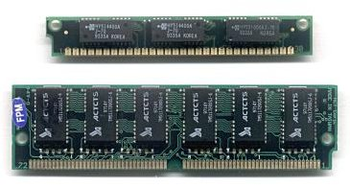30 pin SIMM
2. 72 pin SIMM
3. 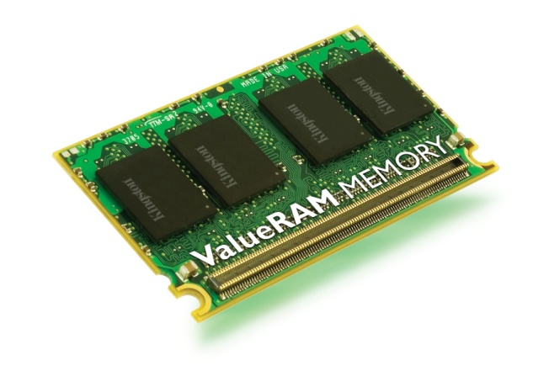MicroDIMM
4. 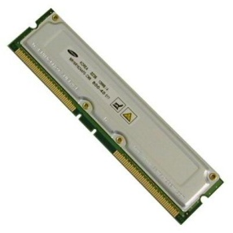184 pin RAMBus RDRAM RIMM
5. 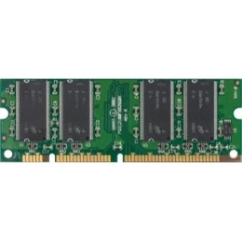100 pin DIMM printer RAM
6. 72 pin SODIMM

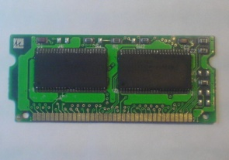

1. 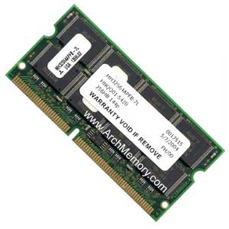144 pin SDRAM SODIMM
2. 200 pin DRR SODIMM

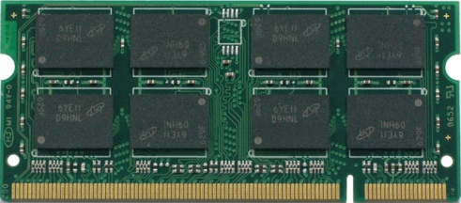

1. 168 pin SDRAM DIMM

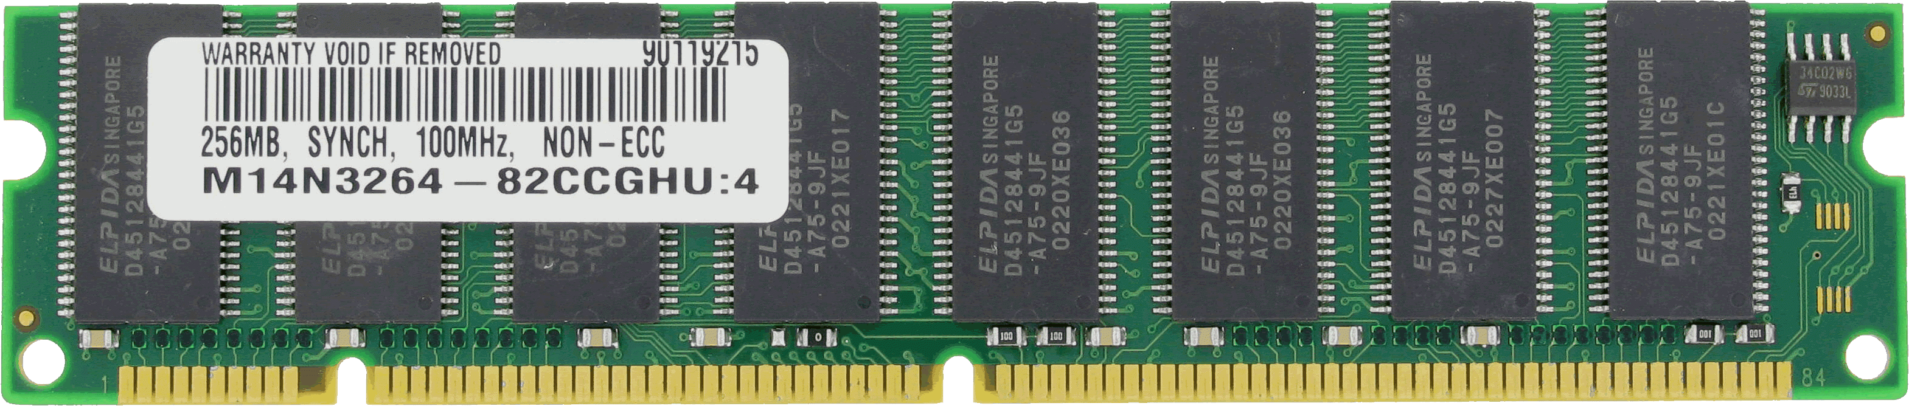

1. 184 pin DDR DIMM

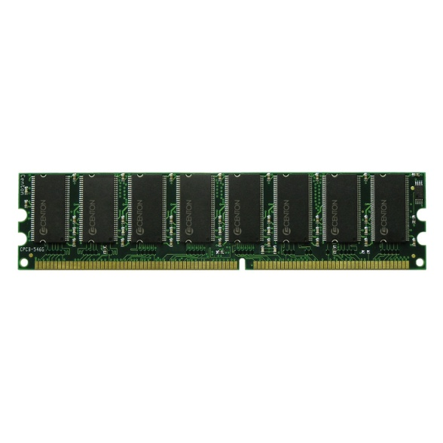

1. 240 pin DDR-2 DIMM

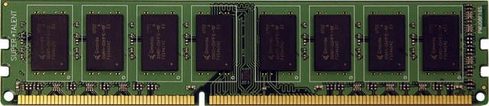

1. 240 pin DDR-2 FB-DIMM, standard & apple heat sink

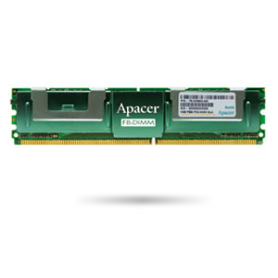

1. 203 pin DDR-3 SODIMM

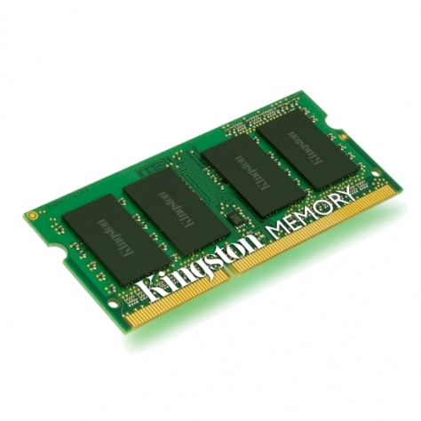

1. 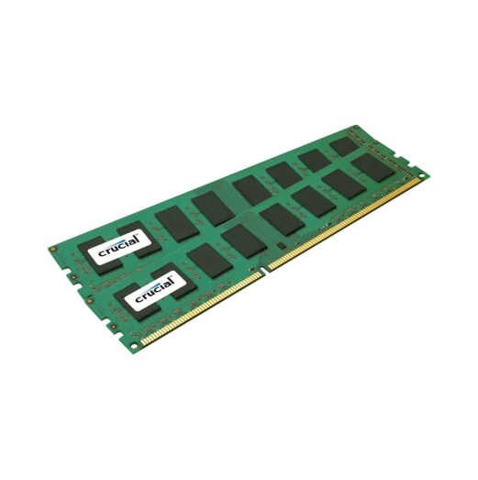240 pin DDR-3 DIMM